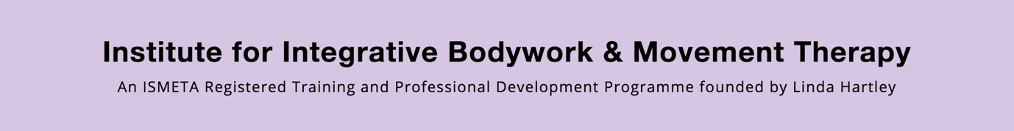

Please complete and return by email to info@ibmt.co.uk

Name:
Address:
Telephone:
Mobile:
E-mail:
Where did you first hear about IBMT?

Briefly describe your interest in this workshop?

Briefly describe your movement experience.

I would like to book for the Introductory IBMT Authentic Movement workshop (s).

Please indicate which date(s) you are booking:

Dates: (limited to 5 participants)

[ ] 19 January 2020
[ ] 19 April 2020
[ ] 7 June 2020
[ ] 23 August 2020

Venue: Willow Studio, 30 Begbie Road, London SE38DA
Time: 1.30pm-5.30pm (arrival from 1pm onwards)
Cost: £180.00 for the series. It is also possible to attend each workshop separately if there are spaces available. £50.00 x 1 workshop.

Cont./
Booking Policy

Please select the date(s) you wish to attend with a cross. When you book a group please note that you are booking for these specific dates. Pay on-line with your name as the Reference.

I …………………………………………….. (sign name here) confirm that I have paid the full fee and note that it is non-refundable unless organizers cancel the event.

Sort Code: 30 90 39
Account No: 28976868
Name: IBMT Administration

Terms & Conditions
All fees are non-refundable.
The organizers reserve the right to cancel the event and will refund any payments made.

The full fee must be paid 4 weeks before the date of the workshop.
Please arrange this – Thank you.

